33rd Sunday in Ordinary Time
Parable of the Talents
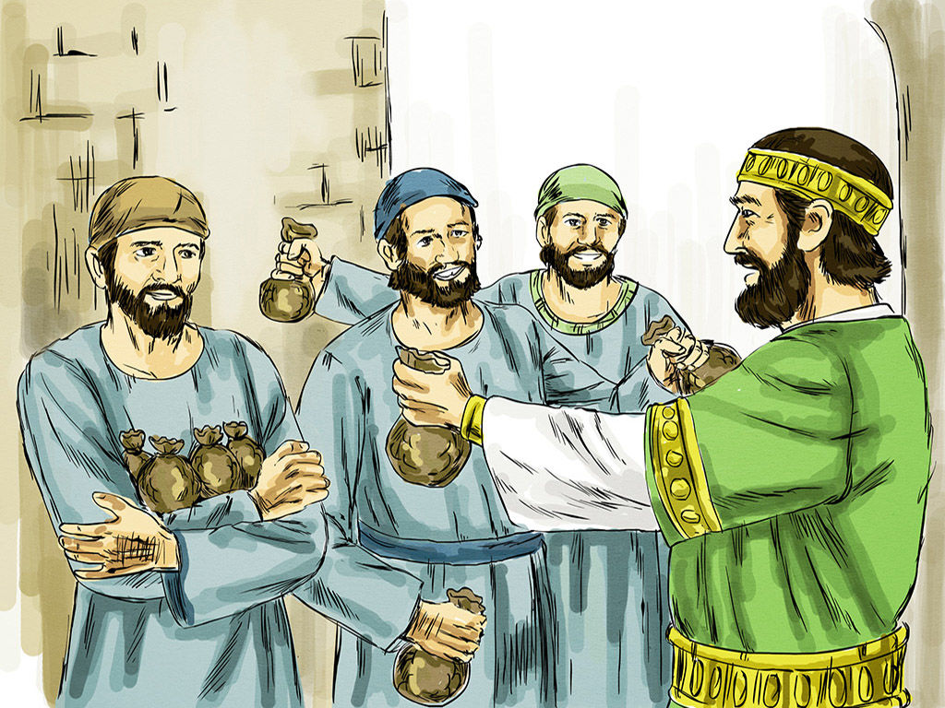

1st Reading: Proverbs: 31:10-13, 19-29, 30-31
The ideally virtuous and industrious wife an Israelite husband hoped to find
A capable wife who can find? She is far more precious than jewels. The heart of her husband trusts in her, and he will have no lack of gain. She does him good, and not harm, all the days of her life. She seeks wool and flax, and works with willing hands. She is like the ships of the merchant, she brings her food from far away. She rises while it is still night and provides food for her household and tasks for her servant girls. She considers a field and buys it; with the fruit of her hands she plants a vineyard. She girds herself with strength, and makes her arms strong. She perceives that her merchandise is profitable. Her lamp does not go out at night. She puts her hands to the distaff, and her hands hold the spindle. She opens her hand to the poor, and reaches out her hands to the needy.
She is not afraid for her household when it snows, for all her household are clothed in crimson. She makes herself coverings; her clothing is fine linen and purple. Her husband is known in the city gates, taking his seat among the elders of the land. She makes linen garments and sells them; she supplies the merchant with sashes. Strength and dignity are her clothing, and she laughs a the time to come. She opens her mouth with wisdom, and the teaching of kindness is on her tongue. She looks well to the ways of her household, and does not eat the bread of idleness.
Her children rise up and call her happy; her husband too, and he praises her: “Many women have done excellently, but you surpass them all.” Charm is deceitful, and beauty is vain, but a woman who fears the Lord is to be praised. Give her a share in the fruit of her hands, and let her works praise her in the city gates.
Responsorial: Psalm 127:1-5
Response: Happy are those who fear the Lord
O blessed are those who fear the Lord
and walk in his ways!
By the labour of your hands you shall eat.
You will be happy and prosper. Resp:
Your wife like a fruitful vine
in the heart of your house;
your children like shoots of the olive,
around your table. Resp:
Indeed thus shall be blessed
the man who fears the Lord.
May the Lord bless you from Zion
in a happy Jerusalem
all the days of your life. Resp:

2nd Reading: 1 Thessalonians 5:1-6
Paul admits that he does not know when the second coming will take place.
But be vigilant!

Concerning the times and the seasons, brothers and sisters, you do not need to have anything written to you. For you yourselves know very well that the day of the Lord will come like a thief in the night. When they say, “There is peace and security,” then sudden destruction will come upon them, as labour pains come upon a pregnant woman, and there will be no escape!
But you, beloved, are not in darkness, for that day to surprise you like a thief; for you are all children of light and children of the day; we are not of the night or of darkness. So then let us not fall asleep as others do, but let us keep awake and be sober.

Gospel: Matthew 25:14-30
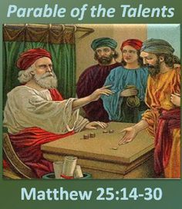

The parable of the Talents is a challenge to use our gifts
to achieve what God expects from us.

Jesus told this parable to his disciples: “The kingdom of heaven is like a man who, before going on a journey, summoned his slaves and entrusted his property to them; to one he gave five talents, to another two, to another one, to each according to his ability. Then he went away. The one who had received the five talents went off at once and traded with them, and made five more talents. In the same way, the one who had the two talents made two more talents. But the one who had received the one talent went off and dug a hole in the ground and hid his master’s money.
After a long time the master of those slaves came and settled accounts with them. Then the one who had received the five talents came forward, bringing five more talents, saying, ‘Master, you handed over to me five talents; see, I have made five more talents.’ His master said to him, ‘Well done, good and trustworthy slave; you have been trustworthy in a few things, I will put you in charge of many things; enter into the joy of your master.’ And the one with the two talents also came forward, saying, ‘Master, you handed over to me two talents; see, I have made two more talents.’ His master said to him, ‘Well done, good and trustworthy slave; you have been trustworthy in a few things, I will put you in charge of many things; enter into the joy of your master.’ Then the one who had received the one talent also came forward, saying, ‘Master, I knew that you were a harsh man, reaping where you did not sow, and gathering where you did not scatter seed; so I was afraid, and I went and hid your talent in the ground. Here you have what is yours.’
But his master replied, ‘You wicked and lazy slave! You knew, did you, that I reap where I did not sow, and gather where I did not scatter? Then you ought to have invested my money with the bankers, and on my return I would have received what was my own with interest. So take the talent from him, and give it to the one with the ten talents. For to all those who have, more will be given, and they will have an abundance; but from those who have nothing, even what they have will be taken away. As for this worthless slave, throw him into the outer darkness, where there will be weeping and gnashing of teeth.’ ”

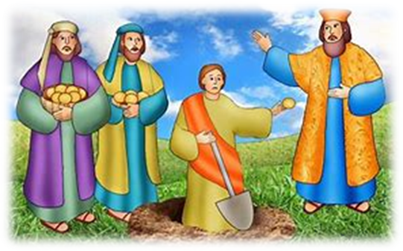

REFLECTIONS:
We know from experience that different people have different abilities. A person with an ability to listen to others may not have the ability to be a good administrator. Someone who is well able to mend a leak or fix a washing machine may have little or no musical ability. An effective teacher may be a hopeless mechanic. We learn from experience whose-good-at-what, and we relate to people accordingly. We tend to entrust people with tasks that are in proportion to their ability. We also learn from experience what our own abilities are, and what our limitations are, and we tend to take on tasks that correspond to our abilities and avoid tasks that do not.
The rich man in today’s parable was well aware of the abilities of his servants. Before he set out on his journey he entrusted his property “to each according to his ability.” He knew what each of his three servants was able for, and he only gave as much responsibility to each of them as each could carry. The man who received five talents of money was capable of making five more; the one who received two talents was capable of making two more; the one who received one talent was capable of making one more. The first two servants worked according to their ability. The third servant did not, giving his master back the one talent he had been given, instead of the two talents he was capable of gaining. What held this servant back from working according to his ability was fear. “I was afraid, and I went and hid your talent in the ground.”
Many of us may find ourselves having some sympathy for the third servant, because, deep down, we are only too well aware how fear can hold us back and prevent us from doing what we are well capable of doing. Fear can be a much more powerful force in the lives of some than others. There can be many reasons for this. Those who have experienced a lot of criticism growing up can be slow to take a risk and may develop a fearful approach to life. Unfair criticism can stunt our growth and prevent us from reaching our God-given potential. We hide what we have been given in the ground. There it remains safe, but useless.
Jesus was only too well aware of the disabling power of fear in people’s lives. It is striking the number of times in the gospels he addresses people with the words, “Do not be afraid.” When Simon Peter fell down at Jesus’ knees saying, “Depart from me, Lord, for I am a sinful man,” Jesus replied to him, “Do not be afraid, from now on it is people you will catch.” When fear threatened to hold Peter back, Jesus called him forward into a new way of life. Jesus was present to people in ways that released them from their fear. In particular, he did not want fear of failure to hold people back. He could cope with failure in others. He knew that many people could learn from failure. There was little to be learned from staying put. There was much to be learnt from striking out, even if failure was experienced along the way.
The tragedy of the third servant in the parable today is that, out of fear, he hid what had been entrusted to him, even though he had the ability to use it well. We have each been graced in some way by the Lord for the service of others. If I hide what the Lord has given me, others are thereby deprived. Most of us need a bit of encouragement to place our gifts at the disposal of others. Part of our baptismal calling is to give others courage, to encourage others. St Paul wrote: “Encourage one another and build up each other, as indeed you are doing.”
In these difficult times for the church, the ministry of encouragement is all the more necessary. There is much to be learned from the mistakes of the past, but the Lord would not want us to go to ground. Now is not the time to hide our Good News in the ground out of fear. Rather, it is a time to encourage each other to share this treasure so that the church may become all that God is calling it to be. Amen.
